**AWS ARCHITECTURE –**

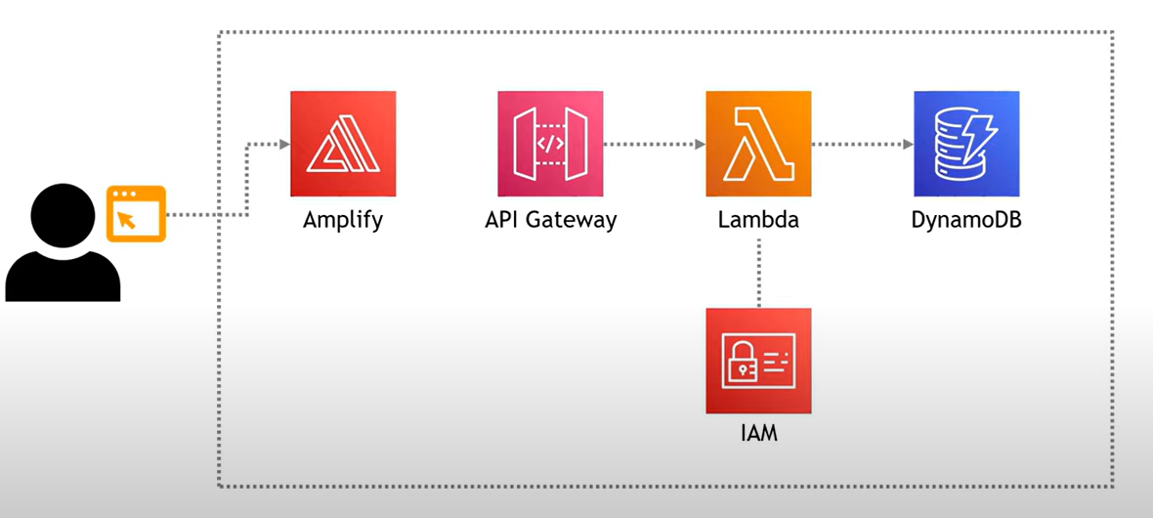

**AWS AMPLIFY—** Build and Host web Applications (using zipped html)(use gateway)

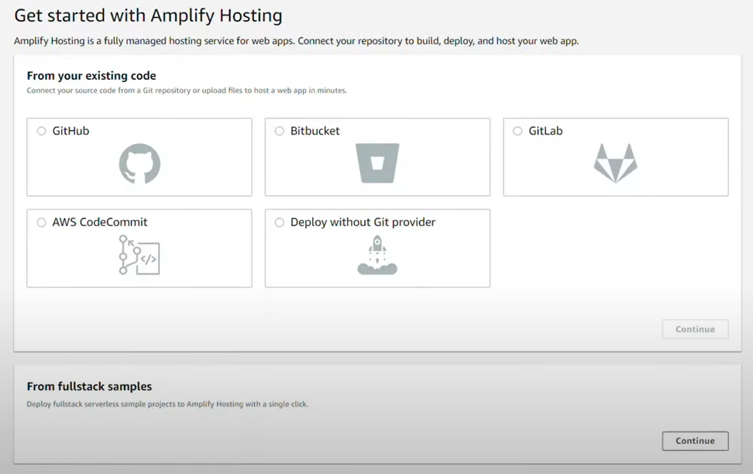

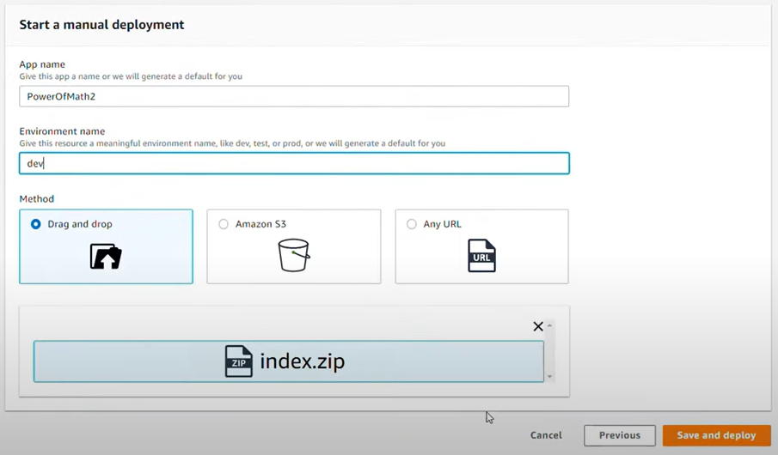

**AWS LAMDA –** do some basic maths calculations (store in dynamo db)

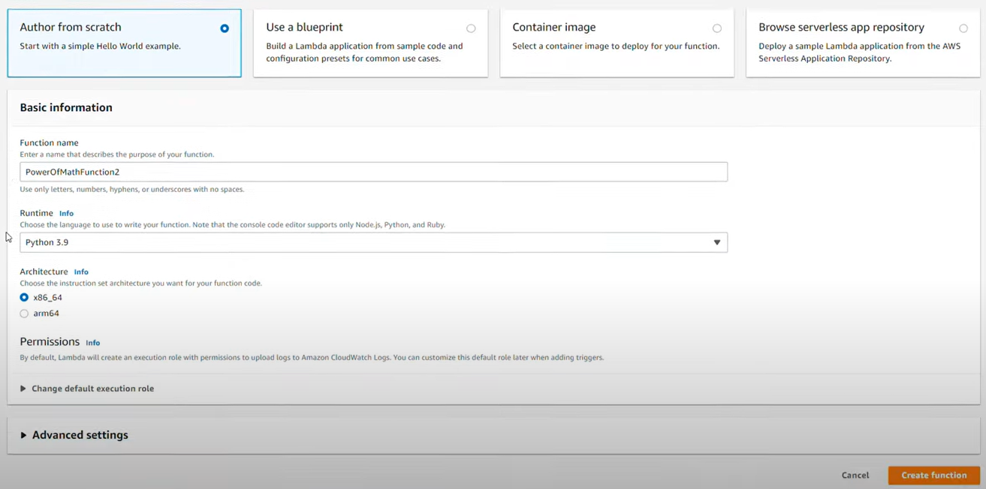

**AWS GATEWAY –** Invoke lambda function and set up triggers.

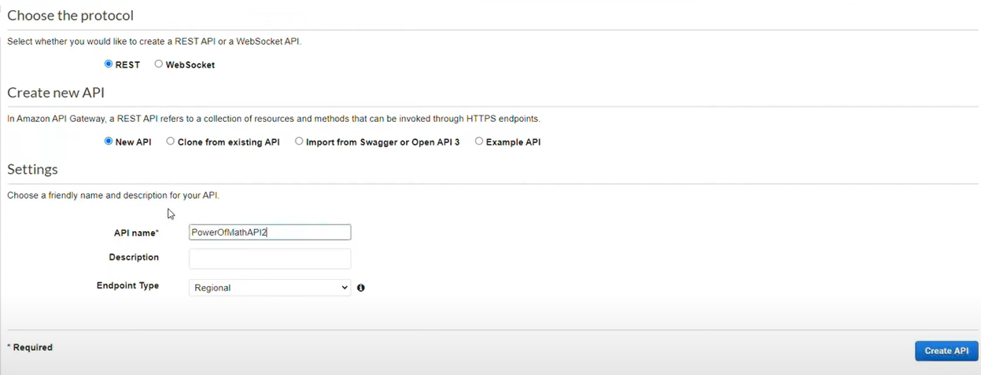

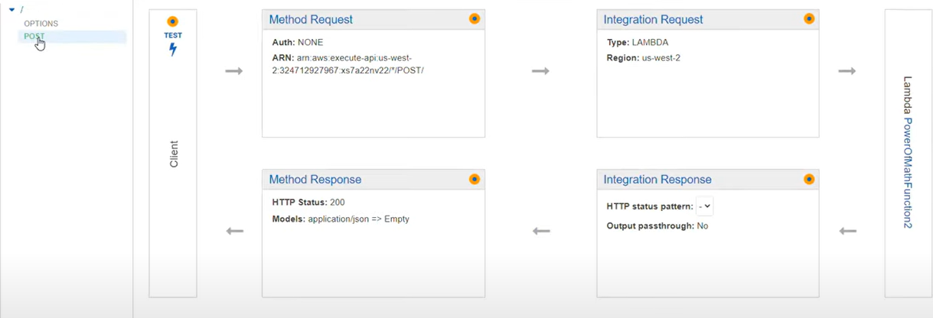

**DYMANO DB –** NoSQL Database used to store outputs

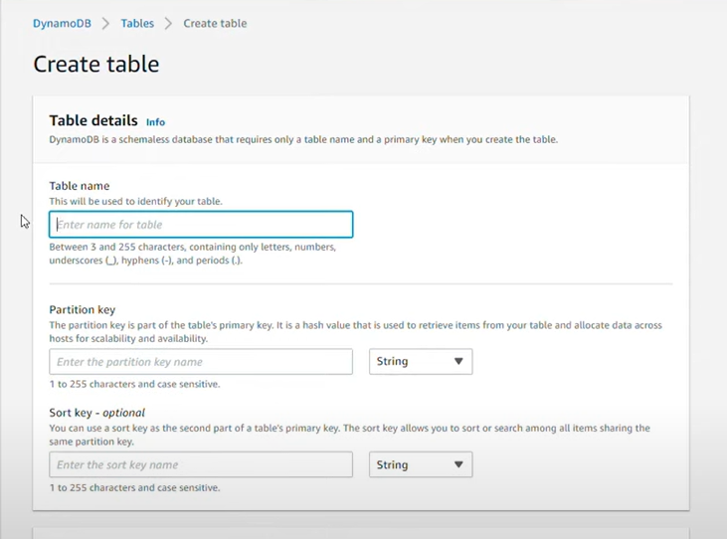

**IAM -**  manage policies for lambda function to write into database.

